**DAILY ONLINE ACTIVITIES SUMMARY**

|  |  |  |  |  |  |  |  |  |
| --- | --- | --- | --- | --- | --- | --- | --- | --- |
| **Date:** | **20-06-2020** | | | | | **Name:** | **Huda Sultana** | |
| **Sem & Sec** | **8 A** | | | | | **USN:** | **4AL16CS039** | |
| **Online Test Summary** | | | | | | | | |
| **Subject** | | **-** | | | | | | |
| **Max. Marks** | | **-** | | **Score** | | | **-** | |
| **Certification Course Summary** | | | | | | | | |
| **Course** | **Introduction to Amazon EC2 Systems Manager.** | | | | | | | |
| **Certificate Provider** | | | **AWS** | | **Duration** | | | **120 mins** |
| **Coding Challenges** | | | | | | | | |
| **Problem Statement:**   1. **Write a C Program to rotate a Matrix by 90 Degree in Anticlockwise Direction.** | | | | | | | | |
| **Status: Solved** | | | | | | | | |
| **Uploaded the report in Github** | | | | | **Yes** | | | |
| **If yes Repository name** | | | | | **Hudasulltana/online_coding** | | | |
| **Uploaded the report in slack** | | | | | **Yes** | | | |

Online Test Details:

Not Conducted

Certification Course Details:

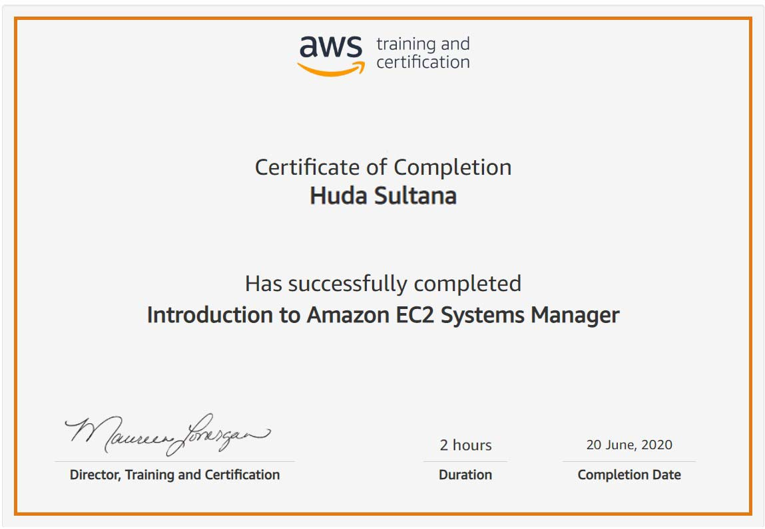

Coding Challenges Details:

**PROGRAM 1 .**

**//Write a C Program to rotate a Matrix by 90 Degree in Anticlockwise Direction.**

**#include <stdio.h>**

**#define N 4**

**void displayMatrix(**

**int mat[N][N]);**

**void rotateMatrix(int mat[][N])**

**{**

**for (int x = 0; x < N / 2; x++) {**

**for (int y = x; y < N - x - 1; y++) {**

**int temp = mat[x][y];**

**mat[x][y] = mat[y][N - 1 - x];**

**mat[y][N - 1 - x] = mat[N - 1 - x][N - 1 - y];**

**mat[N - 1 - x][N - 1 - y] = mat[N - 1 - y][x];**

**mat[N - 1 - y][x] = temp;**

**}**

**}**

**}**

**void displayMatrix(int mat[N][N])**

**{**

**for (int i = 0; i < N; i++) {**

**for (int j = 0; j < N; j++)**

**printf("%2d ", mat[i][j]);**

**printf("\n");**

**}**

**printf("\n");**

**}**

**int main()**

**{**

**int mat[N][N] = {**

**{ 1, 2, 3, 4 },**

**{ 5, 6, 7, 8 },**

**{ 9, 10, 11, 12 },**

**{ 13, 14, 15, 16 }**

**};**

**rotateMatrix(mat);**

**displayMatrix(mat);**

**return 0;**

**}**